**Toeic test 5**

1. **Look at the picture and listen to the sentences. Choose the sentence that best describes the picture:**

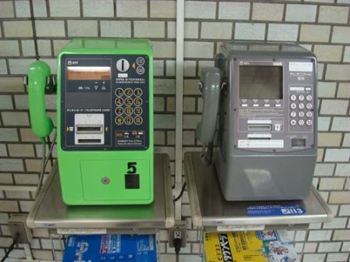

* A
* B
* C
* D

1. **Listen to the question and the three responses. Choose the response that best answers the question:**

* A
* B
* C

1. **Listen to the dialogue. Then read each question and choose the best answer:**

* What does the man suggest the woman do?

1. Visit clients in New York.
2. Create an expense account.
3. Keep a copy of her bills
4. Attend a conference.
5. **Listen to the talk. Then read each question and choose the best answer:**

* What is the caller waiting for?

1. Hospital forms
2. Test results
3. A payment invoice
4. A medical prescription
5. **Choose the word that best completes the sentence:**

* Considering the failure of -------- system to offer adequate support, we might have to provide refunds to our customers.

1. Us
2. Ours
3. Ourselves
4. Ours
5. **Choose the word or phrase that best completes the blanks:**

* There has been considerable discussion about the global shortage of nurses. Most underdeveloped nations do not have the qualified nurse workforce to contend (65)........ their growing health problems let alone improve the health and well-being of their people. Factors (66)........ in the nursing shortage vary among countries. Globally,demand outpaces supply. While in developed nations advances in science brought varied treatment options, ineffective health care systems contributed to those difficult situations in underdeveloped nations. In addition,increased opportunities for other careers for women and failure to (67)........ them to nursing careers are considered to have been factors. In order to overcome the shortage, the supply of new nurses must be increased. Sorry again for the inconvenience. For more information, please contact Donna Maser, the program coordinator, at (518) 437-5961.

1. At
2. In
3. From
4. With
5. **Read the passage and choose the correct answer:**

* Date: April 22

To: All managers

From: Alan Turing

Re: Company Tennis Tournament

Please distribute this notice to all full-time employees.

It’s that time of the year again – time to dust off your racket for our annual company tennis tournament! We were so pleased with the exceptional turn-out last year, and we’re hoping to see all of you again for more fun! We’ll be holding the tournament at the same location as last year, the Lanark Country Club, on Sunday, May 26. The matches start at 1:30, followed by our usual patio party and gourmet barbeque at 6:30. The price has gone up slightly to $40 because our caterer is charging more. But we’re also offering some more valuable prizes this year, including a 62-inch LCD TV for the winner and laptop computers for second and third place. So, we’re hoping to see some competitive spirit! Space is limited to 48; so, hurry and sign up. You can sign up with Ashley Briggs in Accounting. We’re looking forward to seeing you there!

* What reason is given for the slight price increase?

1. Tennis fees have gone up at the Lanark Country Club.
2. The company providing food has raised their prices.
3. The prizes are more expensive this year.
4. Only 48 people are able to attend.